Empowering Communities to Conserve the Mali Elephants

in Times of War and Peace

Summary
The Mali Elephant Project (MEP) has, since 2002, worked with the Malian government and local communities to conserve an internationally important (12% of West African elephants) and iconic elephant population over an area the size of Switzerland. Most recently this involved the local community protecting these 550 elephants throughout the recent multiple conflicts, despite total lawlessness and the proliferation of arms throughout the elephant range. This achievement was, however, only possible because of the firm foundation established pre-conflict in working with the community to develop solutions to human-elephant conflict that benefitted both humans and elephants, and led to an overall decrease in exploitation of natural resources and biodiversity.

The problem
Increasing human pressure throughout the migratory range of the 550 Mali elephants heightens the potential for human-elephant conflict at the same time as natural resource degradation impoverishes livelihoods and reduces ecosystem resilience. And yet the MEP has demonstrated that successful mitigation methods, such as land-use planning and the integration of elephant conservation into community natural resource management plans and development plans, are both possible and effective. In the National Biodiversity Action Plan, Mali has identified the Gourma as an area of great significance. The elephants are singled out as they are regarded of national and international importance representing 12% of all West African elephants, and accorded a high priority in IUCN’s regional elephant strategy, making an amazing circular migration annually from Mali to Burkina Faso and back.

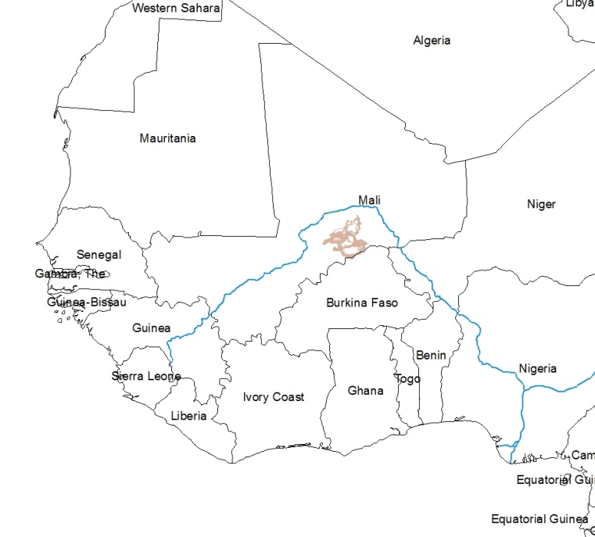
Phase I – the science
In the first phase of the Mali Elephant Project (2003-6), The WILD Foundation (WF) worked with Save the Elephants to understand: how this population of elephants’ use of space enables them to cope with the dispersed and variable nature of the Gourma’s resources; identify the threats to their survival; and determine priorities for action. Action was urgently needed but government resources were wholly inadequate to cover this vast area (over 40,000km²) and a different approach was required, one that engaged the whole system of humans, elephants and the environment to produce elephant conservation.
Figure 1– The elephant migration route (in brown) in relation to West Africa

Phase II – stakeholder engagement
To achieve this, a shared vision for elephants throughout Mali was key. Stakeholder engagement, especially in the rural areas, helped clarify the livelihoods and perspectives of the local people and deepened the MEP’s understanding of the elephants as part of the whole socio-ecological ecosystem. This information was used to develop outreach activities and subsequently to design participatory solutions to human-elephant conflict. It also revealed how the threats to the elephants were the same as the threats to both the livelihoods of the local population and ecosystem resilience of the , and that all were underpinned by the anarchic use of natural resources by multiple interests and ethnicities. This “free-for-all” led to resource degradation, habitat destruction, impoverished livelihoods, and an increase in human-elephant conflict.

Phase III – action on the ground 2009 onwards
Action began at Lake Banzena, the only dry season water available for elephants. This dried prematurely in 2009, making intervention urgent, and it was here that the MEP developed a model that is being replicated across the elephant range, modified to suit local circumstances.
At Banzena, competition for resources was severe, between a recently resident human population, commercial interests, “prestige” herds belonging to distant, wealthy, urban Malians (representing 96% of the cattle population), and the elephants. The MEP team used an iterative participatory process to develop a consensual plan that involved human residents voluntarily relocating to an area outside the elephant range with abundant pasture…the incentives were clean water provided by three new boreholes, better grazing, and placing the resources of the area under the control of the local community. This allowed them to limit resource use, to charge others for access to water, and protect habitat. The management committee designated a 400,000 hectare pastoral reserve that was spontaneously added to by adjacent communes to make a total of 923,800 hectares. Protected by fire-breaks, this was the only part of the northern Gourma not to lose its pasture in bush fires that year, and other communities throughout the elephant range have been asking for help to do the same thing.

Phase IV – the conflict
In March 2012, due to rebellion, a coup, Al Qaeda invasion, government abandoned the area, firearms proliferated and the area was occupied by armed groups. MEP adapted its modus operandi and worked with the people to help address their challenges at the same time as protecting the elephants. Local people were concerned about procuring grain and their youth joining the armed groups. The project brought grain in by donkey cart to avoid hijack and community elders pledged to spread the message (including to the members of armed groups) that killing elephants was actually stealing from the local people. MEP recruited young men in elephant and natural resource protection and, despite being paid only in food, none of the young men recruited by MEP subsequently joined the financially-compensated, armed groups. Service to their communities was regarded as a more “noble” occupation, and the young men were proud to provide food for their families.

Why do the local people protect the elephants?
The local people receive benefits from establishing natural resource management systems as it means more resources are available, they have control over them, they receive revenue from charging for access of prestige herds to water, and their young men have a useful occupation. Do they need elephants to do this? Maybe not, but our surveys and work with them reveal important attitudes. Elephants attract national and international attention, and they are proud of that. They view elephants as an indicator of a healthy ecosystem upon which their livelihoods depend. They also know that elephants are important as seed dispersers and in forest regeneration; they knock down inaccessible fruits and seeds from high branches that are gathered for food and eaten by livestock, and they use the dung to help conjunctivitis. They feel wonder at elephant behavior, believe that every species has a right to exist, and contributes something unique to the ecosystem. There is also the additional possibility of tourism revenue when peace is restored. Together, these produce an overall benefit that is greater than the sum of the parts.﻿

“We don’t want the elephants to disappear because if the elephants disappear it means the ecosystem is no longer good for us.” Malian villager
More information at http://www.wild.org/where-we-work/the-desert-elephants-of-mali/; and a 10 minute Tedx video telling the story of the project at http://bit.ly/KwOrxd

